Class Activity - Linked In!
Objectives
Connect devices using wired and wireless media.
Physical Topology
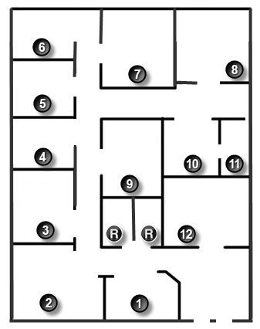

Background /Scenario
Note: This activity is best completed in groups of 2-3 students.
Your small business is moving to a new location! Your building is brand new, and you must come up with a physical topology so that network port installation can begin.
Your instructor will provide you with a blueprint created for this activity. The area on the blueprint, indicated by Number 1, is the reception area and the area numbered RR is the restroom area.
All rooms are within Category 6 UTP specifications (100 meters), so you have no concerns about hard-wiring the building to code. Each room in the diagram must have at least one network connection available for users/intermediary devices.
Do not go into excessive detail on your design. Just use the content from the chapter to be able to justify your decisions to the class.
Required Resources
- Packet Tracer software
Reflection
- Where would you locate your network main distribution facility, while keeping security in mind?
_______________________________________________________________________________________
_______________________________________________________________________________________
- How many intermediary devices you would use and where would you place them?
_______________________________________________________________________________________
_______________________________________________________________________________________
- What kind of cabling you would use (UTP, STP, wireless, fiber optics, etc.) and where would the ports be placed?
_______________________________________________________________________________________
_______________________________________________________________________________________
- What types of end devices you would use (wired, wireless, laptops, desktops, tablets, etc.)?
_______________________________________________________________________________________
_______________________________________________________________________________________

